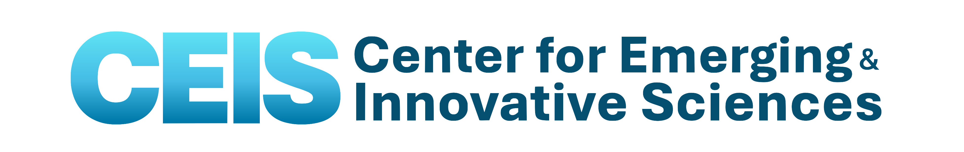
To: Faculty Researchers

From: Mark F. Bocko – CEIS Director
Re: CEIS Collaborative Innovative Research (CIR) Request for Proposals (RFP)
Date: April 21, 2026

The Center for Emerging and Innovative Sciences, CEIS, is soliciting proposals for the Collaborative Innovative Research Program for the 2026/27 program year.
Research proposals requested: The attached forms constitute a solicitation of research proposals for consideration for funding in the 2026/2027 program year (7/1/2026 – 6/30/2027). CEIS is a NYSTAR (Empire State Development Division of Science, Technology and Innovation) designated Center for Advanced Technology (CAT) funded by NY State. Proposals will be reviewed in May 2026, for projects to commence on July 1, 2026 subject to the availability of funds. The goal of the CEIS CIR program is to stimulate economic growth in NY State by promoting technology transfer from our universities to New York companies. Proposed projects must involve a NY industry partner that is actively engaged with the research, financially sponsoring the research, and willing to provide ongoing economic impact reporting for the project.
Who may apply: The CIR program is open to Principal Investigators (PIs) from the faculties of the University of Rochester, the Rochester Institute of Technology and other regional universities. Persons eligible to be PI’s must be full-time faculty or hold a similar position in their university. Note that only university PIs are eligible for CIR funding. CEIS does not award funds directly to companies.
Types of projects considered: CEIS support traditionally spans a broad range of optics, photonics and imaging interests, including ophthalmic and vision science, fiber optic communications, biomedical imaging, geospatial imaging, precision optics, consumer imaging and displays. Proposals in other technical areas will be considered as well.
Award specifics: In general, awards are computed as one-half the dollar value (excluding qualifying “in kind” contributions) of designated funds from NYS companies. Travel expenses are not allowed on the CEIS portion of the award. Equipment purchased is considered the property of the CAT. F&A on the CEIS awarded funds is restricted to 15% on payroll expenses (salary and benefits) only and may be allowed at a reduced rate of 25% of payroll expenses only on the company matching funds with Dean’s Office approval. CEIS awards are capped at $40,000 per proposal; for companies and researchers with multiple projects, total awards are capped at $60,000 per faculty researcher and $80,000 per company partner. Submission of a new proposal is required for all 2026/2027 funding, even for continuing projects.
New this funding cycle: The CEIS contract with NYSTAR/ESD requires us to actively solicit bids for contracts and/or utilize vendors from qualified State certified MBEs, WBEs, or Service Disabled Veteran Owned Businesses (SDVOBs) for budget items such as office and lab supplies, equipment (including computers), and subcontracts. Your help in identifying and supporting NYS certified M/WBE and SDVOBs will help us meet this requirement. Eligible suppliers/vendors may be found on the following websites: https://www.osc.ny.gov/state-vendors/resources/minority-and-women-owned-business-enterprises-mwbes and https://www.osc.ny.gov/state-vendors/sdvob.
Selection of proposals for awards: For each category of projects, proposals will be ranked by an external review panel and the awards will be given according to rank to the funding maximum. We anticipate making awards for a July 1, 2026 start date subject to the availability of funds. The criteria for evaluation will be based on:
- Scientific and technical merit
- Potential economic impact on the state of New York
- Demonstrated technical accomplishments and economic impact (for continuing projects)
- Level of corporate support relative to requested NYSTAR funding (minimum of 2:1 required)
- Consistency with the technical themes and strategic interests of CEIS (exceptions on a case by case basis)

Scientific and technical merit: The scientific and technical quality of the proposed fundamental or applied research or development activities is assessed by external expert reviewers. The proposal should clearly and succinctly state the problem, objectives, methodology, work plan and deliverables of the project.
Economic impact: Ranking also is dependent upon the potential jobs and revenues that will result from the proposed projects. PIs are strongly encouraged to work closely with their industrial sponsors on the Economic Impact portion of their proposals to give realistic quantitative estimates of the expected impact.
Proposal submission: All proposals must be submitted by email as attachments using the forms on the CEIS web site at http://www.ceis.rochester.edu/funding/CIRP.html. Please note: Documentation of company commitment must accompany the proposal. Proposals will not be reviewed if this is missing. Proposals must be received by Cathy Adams (cathy.adams@rochester.edu) not later than May 20, 2026. RIT proposals are to be initiated in Novelution approximately a week prior to the program deadline.
Award announcement questions: Proposals will be reviewed and awards announced to PIs, their account administrators, and industry contacts by the end of June. Questions about the proposals or the CIR RFP process may be addressed to Cathy Adams (cathy.adams@rochester.edu).

